NAME: JATIN CHOWDHARY

STUDENT ID: 4 0 0 0 3 3 0 1 1

MUSCLE PHYS. & EMG ACTIVITY

LAB TA: CHRISTINE

**Results**

Figure 1 graphs the relationship between Emg (mV) and Force (kg) for subject’s dominant hand. Subject’s dominant hand is right. Figure 2 graphs the relationship between Emg (mV) and Force (kg) for subject’s non-dominant hand. Subject’s non-dominant hand is left. The slope of Figure 1 is 36.283, and the slope of Figure 2 is 26.723. The slope of figure 1 is steeper than figure 2. The R-Squared value of Figure 1 is 0. 91639, and the R-Squared value of Figure 2 is 0. 92393. According to Table 1, subject was able to exert a force of 26.1205 kg with dominant hand, and 18.5755 kg with non – dominant hand. Furthermore, subject’s dominant hand took 55.911 seconds to fatigue, and non – dominant hand took 36.289 seconds to fatigue. Subject’s dominant hand has a forearm circumference of 22.5 cm, and subject’s non-dominant hand has a forearm circumference of 22.4 cm. Appendices 1 to 4 illustrate subject’s EMG’s of antagonistic muscle.

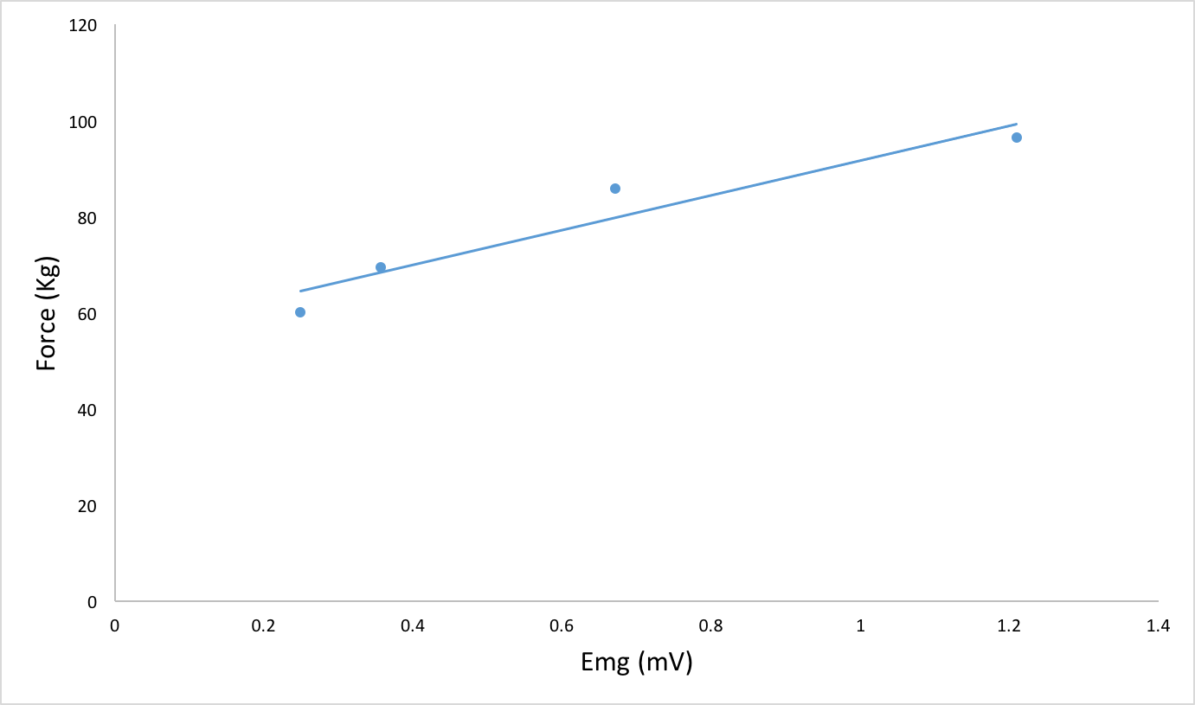

Figure 1: Graphs Emg (mV) against Force (Kg) for Subject's Dominant (Right) Hand. R – Squared Value = 0.91639, And Slope = 36.283

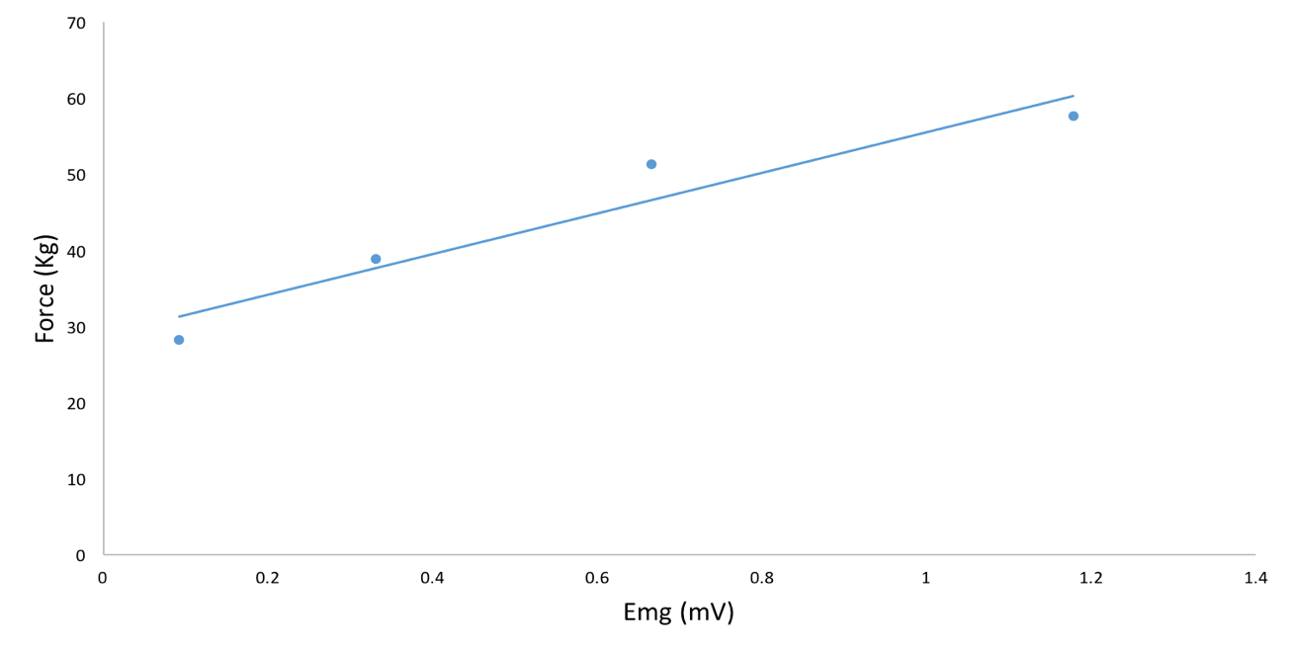

Figure 2: Graphs Emg (mV) against Force (Kg) for Subject's Dominant (Left) Hand. R – Squared Value = 0.92393, And Slope = 26.723

**Discussion**

This experiment tests the correlation between dominant and non – dominant hand strength. Earlier studies have “concluded that the dominant hand is significantly stronger in right handed subjects but no such significant difference… for left handed people” (Incel, Ceceli, Durukan, Erdem, & Yorgancioglu, 2002). (A) According to the data collected and summarized in Figure 1, Figure 2, and Table 2, there is a correlation between the area under the EMG trace for each clench and the force of the clench. The R-Squared value for Figure 1 is 0. 91639, and 0.92393 for Figure 2. This suggests that the linear models fit the set of observations. However, no definitive conclusions can be made from the data without more research. The data can be used to explain the physiology of the human body. (B) As the weights increase in weight, the amplitude and duration of the EMG signal also increases. Furthermore, the number of motor units recruited and number of times each unit is stimulated also increases. As the weight gets heavier, more units are stimulated to recruit more motor units, and enable the subject to lift the object. (C) Based on the object, and duration, the neurons recruit different fibers. When lifting a heavy object, fast glycolytic fibers are recruited to enable the muscle to contract. Fast glycolytic fibers are recruited because they are stronger, and larger. When the subject is required to squeeze a ball for as long as possible, the neurons recruit slow oxidative fibers that are fatigue resistant. (D) This trend carries forward from the dominant arm to the non-dominant arm. However, the dominant arm produces larger EMG signals due to it being able to recruit more muscle fibers. The weaker forearm generates an EMG signal similar to the shape of the stronger forearm, but on a smaller magnitude. (E) Interestingly enough, forearm strength / endurance does not relate to the forearm circumference. The subject’s dominant hand has a forearm circumference of 22.5cm, and non-dominant hand has a forearm of 22.4cm. Both hands have an identical forearm circumference but the dominant hand can exert more force and endurance than the non-dominant hand. (F) The difference in the circumference of the forearms, is unlikely to be caused by a difference in the total number of muscle fibers in the forearm. There can be many different factors attributing to this difference such as body fat. (G) During bicep relaxation, the antagonistic muscles are recruited. This is because during the bicep curl, when the weight is brought closer to the chest, the biceps contract, and the antagonistic muscles relax. Then, when the weight is brought down to the abdomen area, the bicep relaxes, and the antagonistic muscles are recruited, and they contract. (H) This pattern of muscle shortening and lengthening can be qualitatively seen by mapping the EMG signals (Refer to Appendix 1 – 4). The graph is symmetrical on both sides. This is because equal amounts of fibers are recruited in the biceps and triceps to help curl the muscle.

**References**

Al-Timemy, A. H., Khushaba, R. N., Bugmann, G., & Escudero, J. (2016, June 24). Improving

the Performance Against Force Variation of EMG Controlled Multifunctional Upper-

Limb Prostheses for Transradial Amputees. Retrieved February 07, 2017, from

https://www.ncbi.nlm.nih.gov/pubmed/26111399

Armstrong, C. A., & Oldham, J. A. (1999, August 24). A comparison of dominant and non-

dominant hand strengths. Retrieved February 07, 2017, from

https://www.ncbi.nlm.nih.gov/pubmed/10473148

Incel, N. A., Ceceli, E., Durukan, P. B., Erdem, H. R., & Yorgancioglu, Z. R. (2002, May). Grip

strength: effect of hand dominance. Retrieved February 07, 2017, from https://www.ncbi.nlm.nih.gov/pubmed/12188074

Raez, M., Hussain, M., & Mohd-Yasin, F. (2006, March 23). Techniques of EMG signal

analysis: detection, processing, classification and applications. Retrieved February 07,

2017, from https://www.ncbi.nlm.nih.gov/pmc/articles/PMC1455479/

Stanfield, C. L., & Germann, W. J. (2011). *Principles Of Human Physiology* (4th ed.). San

Francisco, CA: Pearson/Benjamin Cummings.

**Appendix**

Table 1: Contains EMG Intensity, Force, Fatigue, & Circumference Of Dominant & Non – Dominant Arm For Subject.

|  |  |  |
| --- | --- | --- |
|  | Non – Dominant Hand | Dominant Hand |
| Max Force (Kg) | 18.5755 | 26.1205 |
| Time To 50% Fatigue | 36.289 | 55.911 |
| Forearm Circumference (Cm) | 22.4 | 22.5 |

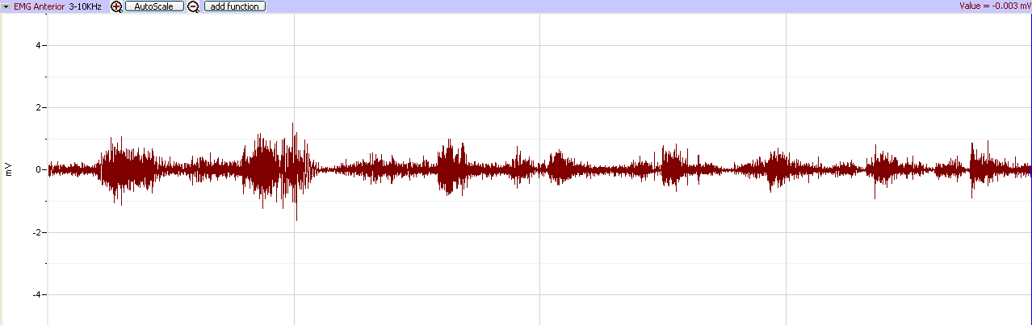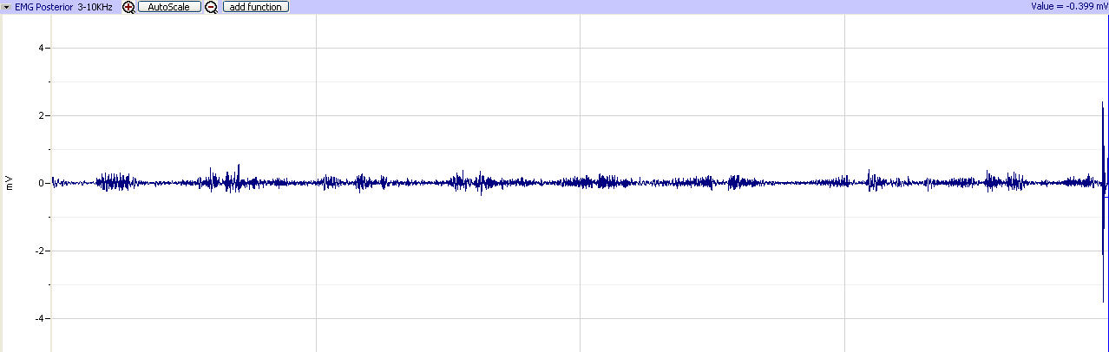

Appendix 1: EMG In Antagonistic Muscle [No Weight]

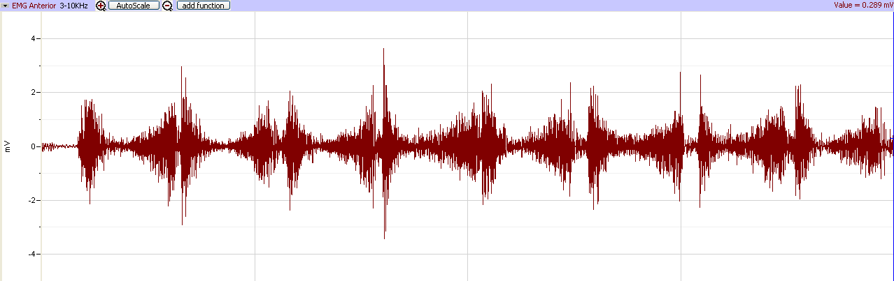

Appendix 2: EMG In Antagonistic Muscle [Weight = 5lbs]

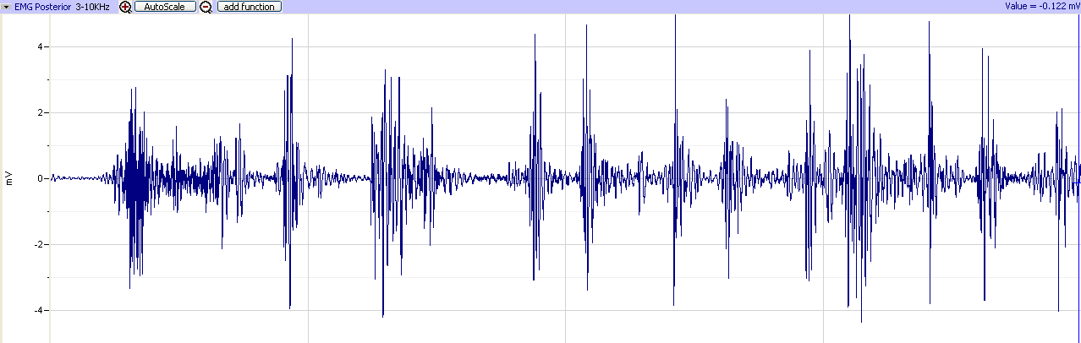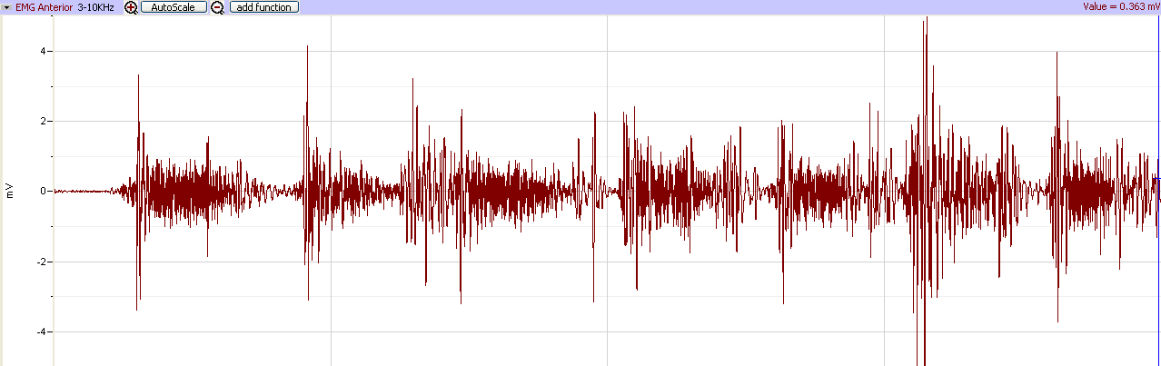

Appendix 3: EMG Of Triceps [No Weight]

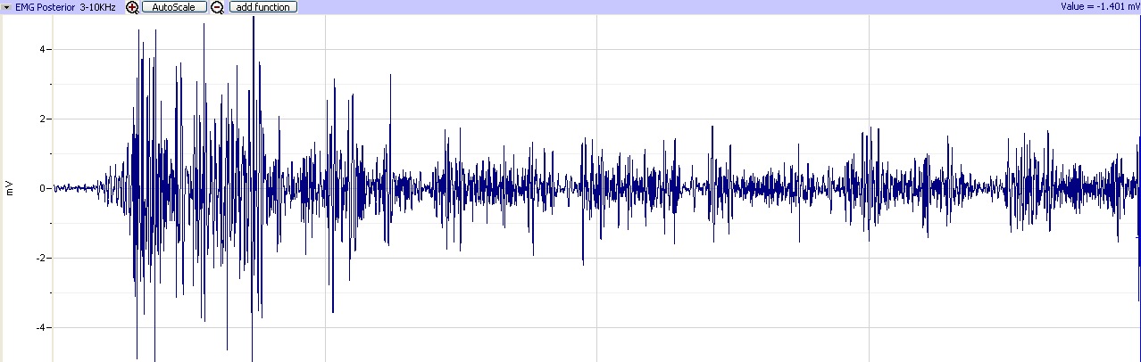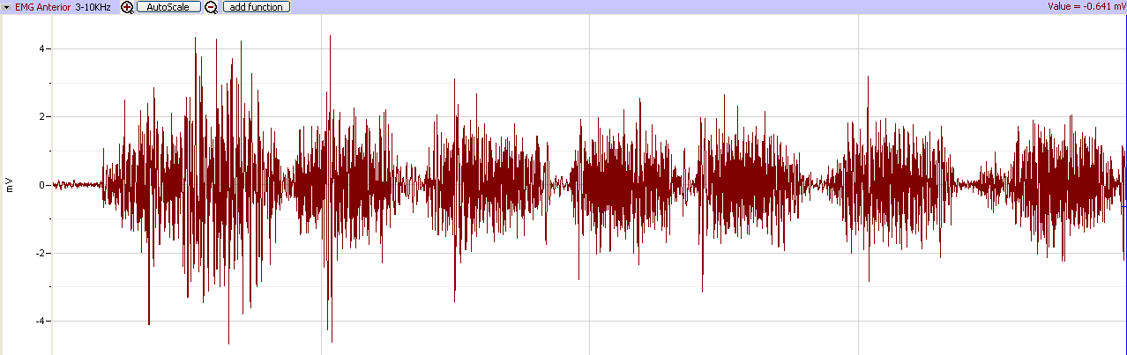

Appendix 3: EMG Of Triceps [With Weight]